**Student Name: Tadhg Corlett**

**Student Number: D00247026**

**Lab 1 – Introduction to Networking Lab**

**Introduction**

This lab will introduce you to the Networking lab and give you an opportunity to identify some physical components of a Network. It will also get you thinking about how a network is structured and how all the different components work together.

**Objectives**

* Draw a Network Diagram
* Demonstrate knowledge of the Layers of the OSI Model
* Identify Devices that operate at each Level of the OSI Model

**Tasks**

**Task 1: Draw a Network Diagram**

In the space below, draw a Physical Network Diagram showing how your Lab Computer connects to the DKIT network.

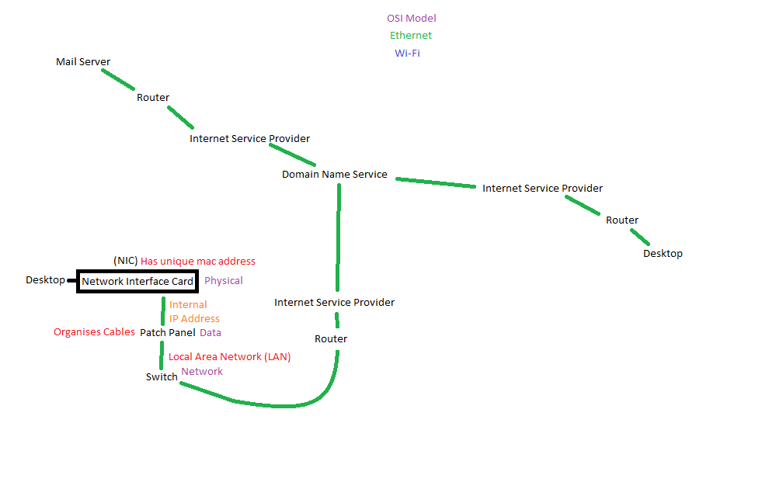

**Task 2: Answer the following questions relating to the Physical Network?**

1. What type of Network Topology is used in P1147?

Star

1. Name three characteristics of this Topology?

One main centre point: Switch

All devices connect directly to the switch.

All communication between these devices takes place within the LAN, connected by the switch.

1. Name one disadvantage of this Topology?

One main point of failure, if the switch breaks the entire network is unusable.

1. What is the name of the device that connects each computer (node) in P1147 together?

Switch.

1. Is the network in P1147 a LAN, WAN or MAN?

LAN.

1. What is the network bandwidth on each computer?

Ethernet

1. Is each computer in P1147 configured as a Peer to Peer computer or a Client Server?

Client Server

**Task 3: Answer the following questions relating to the OSI Model**

1. What do the letters OSI stand for?

Open Systems Interconnection

1. Using a Diagram, list and describe each Layer of the OSI Model.

**Application** – The application layer is where protocols such as http and ftp are used to communicate with the network.

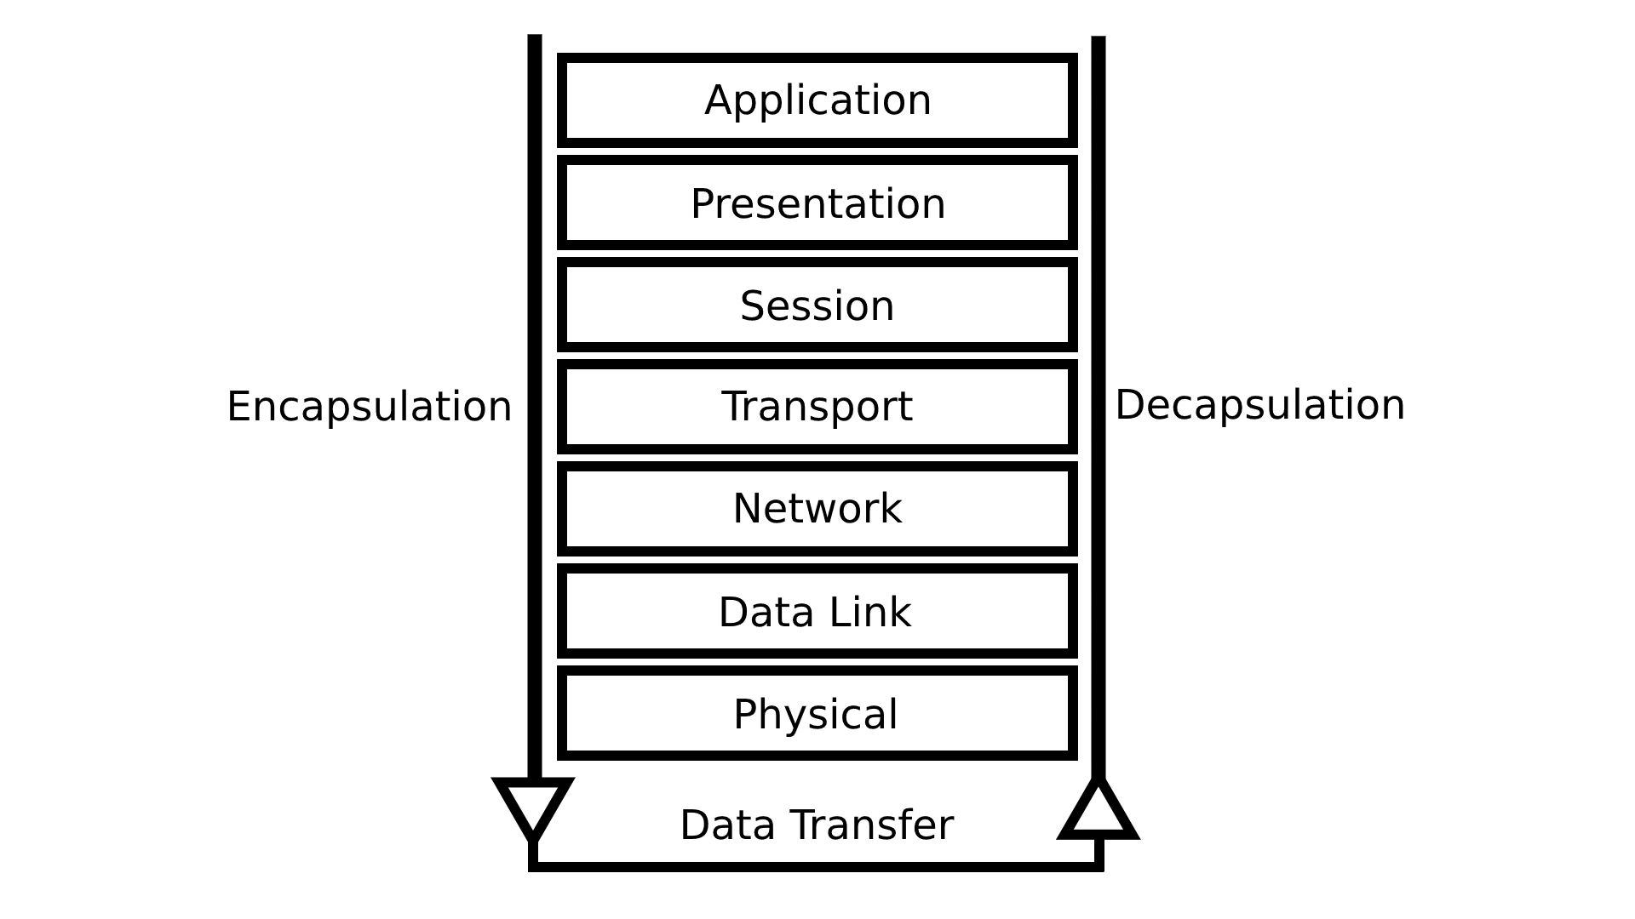

**Presentation** – The presentation layer prepares data for transport based on its file type.

**Session** – The session layer maintains a connection between devices.

**Transport** – The transport layer ensure that data is transferred properly and reliably.

**Network** – The network layer finds and connects the device to another.

**Data Link –** The data link layer manages packets sent and received.

**Physical –** The physical layer manages actual sending and receiving of the data, through the Network Interface Card and the Ethernet cables or wireless connections.

1. Divide the OSI Layers up by Hardware and Software, which layers are Hardware and which are Software.

All of the layers are software based until the Network Layer.

1. Using the Diagram you created in Task 1, identify which layer of the OSI Model each hardware component operates at.

The Network Layer features hardware such as routers.

The Data Link Layer features hardware such as switches and network interface cards.

The Physical Layer features hardware such as cables and repeaters.

**Task 4: List of Network Commands**

*Write out a list of commands you used to identify networking configurations*

Ping – Sends a packet to another device to receive feedback and response times.

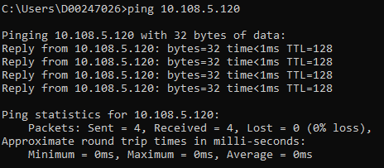

Ipconfig/Ifconfig – Gives information about the current device and the network, including IP addresses.

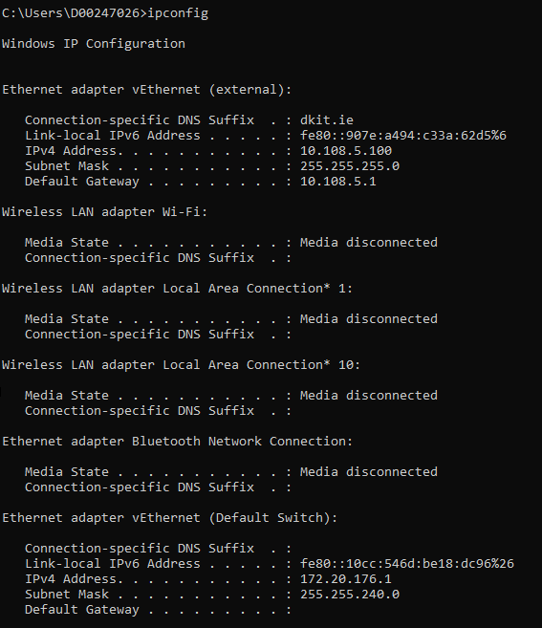

**Conclusion**

*[In this section, write a short Conclusion on what you achieved in this lab; what you found difficult, etc]*

Overall it was a very nice lab and was very informative on the OSI Model and network layout.

I was already aware of the commands used such as ipconfig/ifconfig which I have used prior for things such as port forwarding.